1.LED BLINK ALTERNATIVELY IN ARDUINO

int led1 = 0;

int led2 = 1;

int led3 = 2;

int led4 = 3;

int led5 = 4;

void setup() {

pinMode(led1, OUTPUT);

pinMode(led2, OUTPUT);

pinMode(led3, OUTPUT);

pinMode(led4, OUTPUT);

pinMode(led5, OUTPUT);

}

void loop() {

digitalWrite(led1, HIGH);

delay(80);

digitalWrite(led1, LOW);

digitalWrite(led2, HIGH);

delay(80);

digitalWrite(led2, LOW);

digitalWrite(led3, HIGH);

delay(80);

digitalWrite(led3, LOW);

digitalWrite(led4, HIGH);

delay(80);

digitalWrite(led4, LOW);

digitalWrite(led5, HIGH);

delay(80);

digitalWrite(led5, LOW);

delay(500);

}

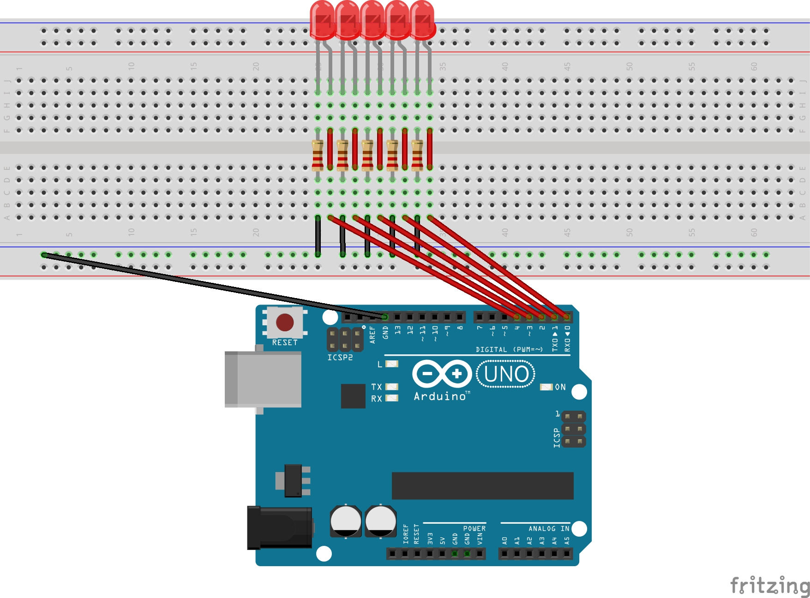

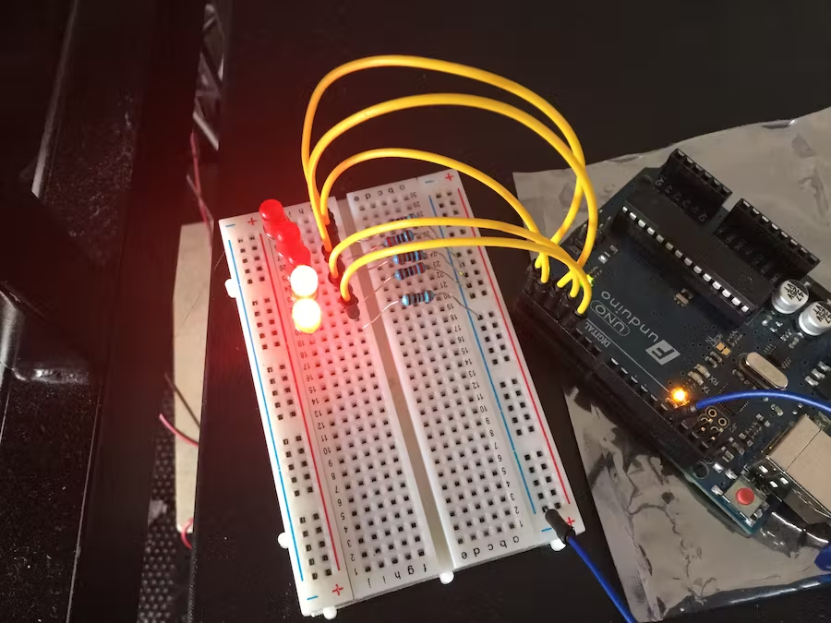

2.ARDUINO TO NUMBER PROVIDED BY USER THROUGH SERIAL MONITORTO MAKE LED GLOW

void setup()

{

Serial.begin(9600);

for (int LEDpin = 6; LEDpin <13 ; LEDpin++) {

pinMode(LEDpin, OUTPUT);

}

}

void loop()

{

int a = 3;

switch (a)

{

case 1:

digitalWrite(6, HIGH);

break;

case 2:

digitalWrite(8, HIGH);

break;

case 3:

digitalWrite(11, HIGH);

break;

case 4:

digitalWrite(12, HIGH);

break;

default:

for (int LEDpin = 6; LEDpin <13; LEDpin++)

{

digitalWrite(LEDpin, LOW);

}

}

}

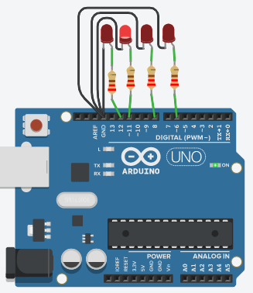

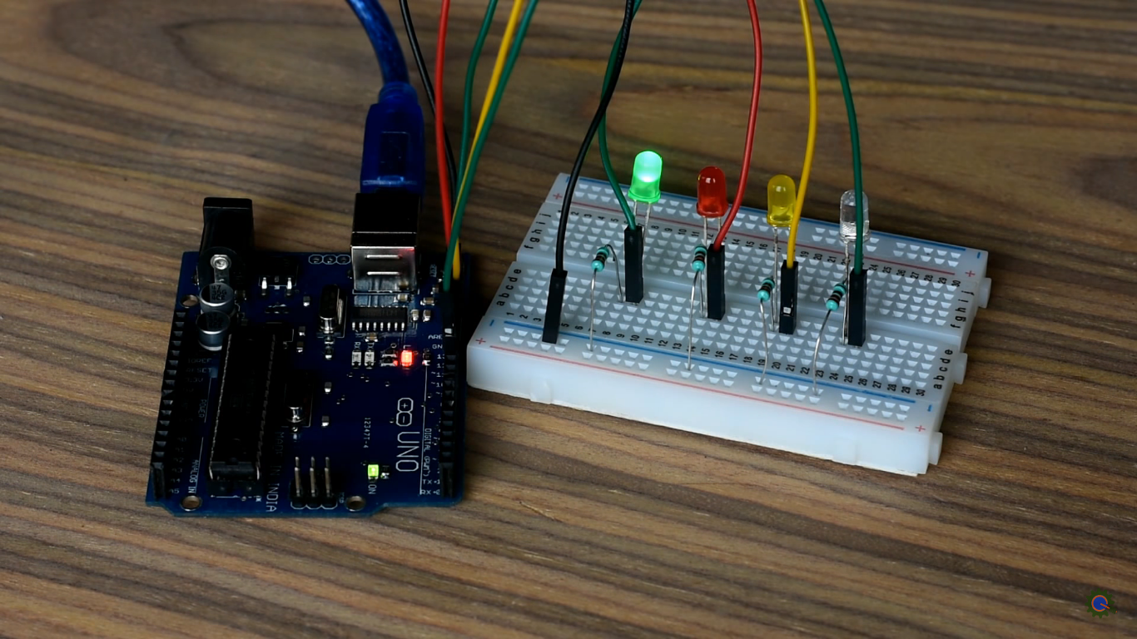

3.MAKE LED GLOW BASED ON RANDOM NUMBER GENERATED USING RASPERRY Pi

import RPi.GPIO as GPIO

from time import sleep

import random

GPIO.setmode(GPIO.BOARD)

pins = [15,16,18,22]

for pin in pins:

GPIO.setup(pin, GPIO.OUT)

try:

while True:

x = random.randint(0,3)

if x is 0:

GPIO.output(15,1)

sleep(.3)

GPIO.output(15,0)

if x is 1:

GPIO.output(16,1)

sleep(.3)

GPIO.output(16,0)

if x is 2:

GPIO.output(18,1)

sleep(.3)

GPIO.output(18,0)

if x is 3:

GPIO.output(22,1)

sleep(.3)

GPIO.output(22,0)

except KeyboardInterrupt:

GPIO.cleanup()

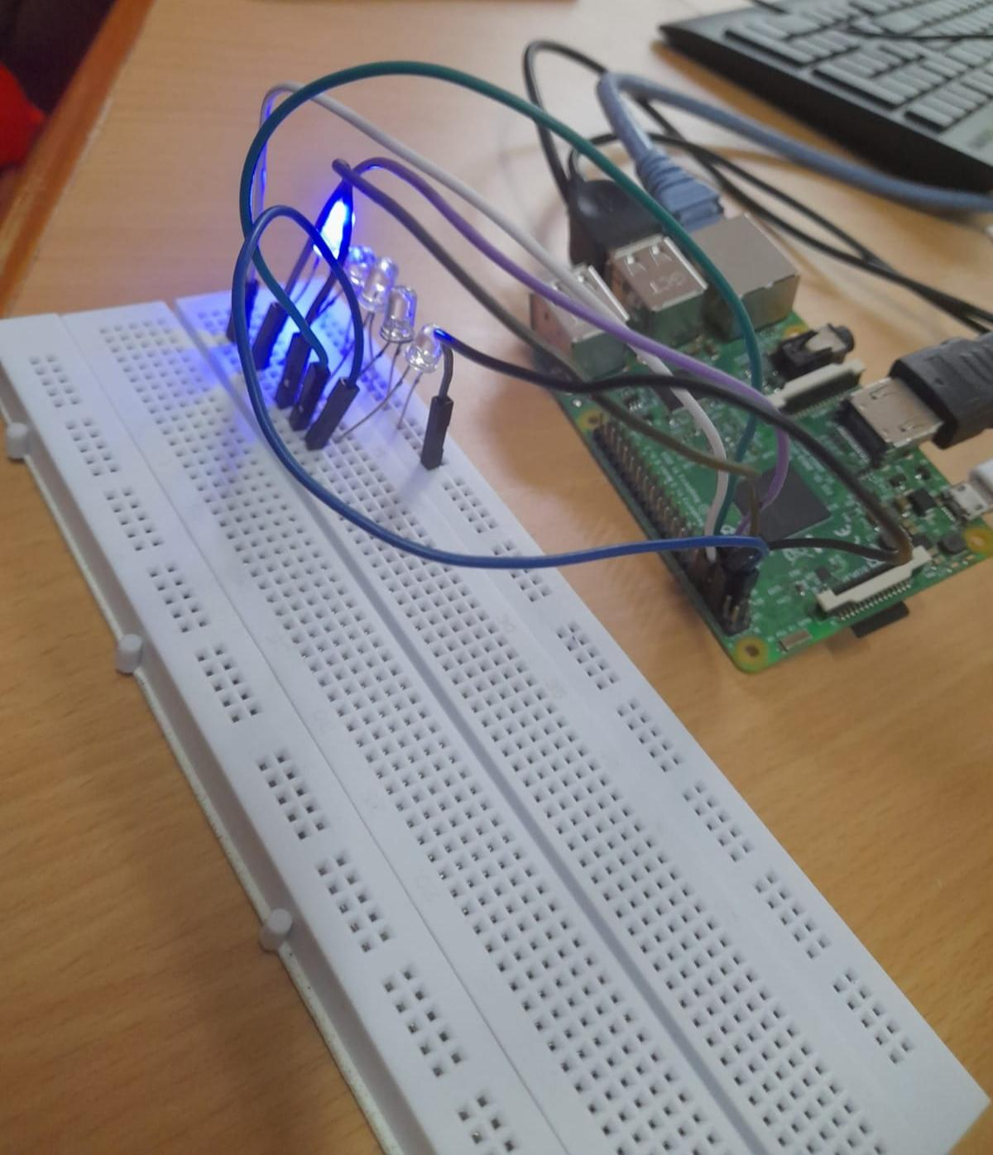

1.Identify object using ir sensor - arduino

int led = 13;

int sensor = 2;

int state = LOW;

int val = 0;

void setup() {

pinMode(led, OUTPUT);

pinMode(sensor, INPUT);

Serial.begin(9600);

}

void loop(){

val = digitalRead(sensor);

if (val == HIGH) {

digitalWrite(led, HIGH);

delay(100);

if (state == LOW) {

Serial.println(val);

Serial.println("Motion detected");

state = HIGH;

}

}

else {

digitalWrite(led, LOW);

delay(200);

if (state == HIGH){

Serial.println(value);

Serial.println("No Motion detected");

state = LOW;

}

}

}

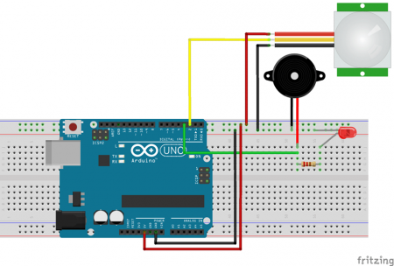

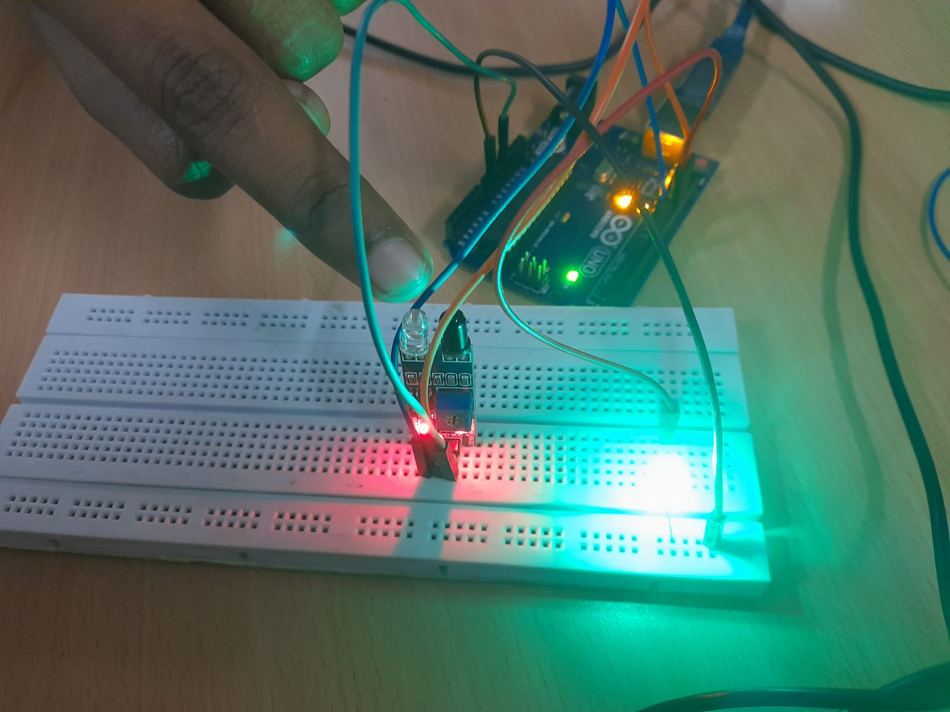

2.identity object using PIR sensor - raspberry PI

import RPi.GPIO as GPIO

import time

sensor = 16

buzzer = 18

GPIO.setmode(GPIO.BOARD)

GPIO.setup(sensor,GPIO.IN)

GPIO.setup(buzzer,GPIO.OUT)

GPIO.output(buzzer,False)

print "Initialzing PIR Sensor......"

time.sleep(12)

print "PIR Ready..."

print " "

try:

while True:

if GPIO.input(sensor):

GPIO.output(buzzer,True)

print "Motion Detected"

while GPIO.input(sensor):

time.sleep(0.2)

else:

GPIO.output(buzzer,False)

except KeyboardInterrupt: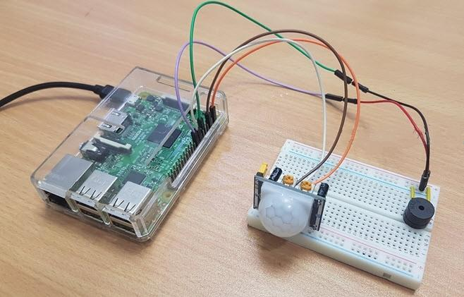

GPIO.cleanup()

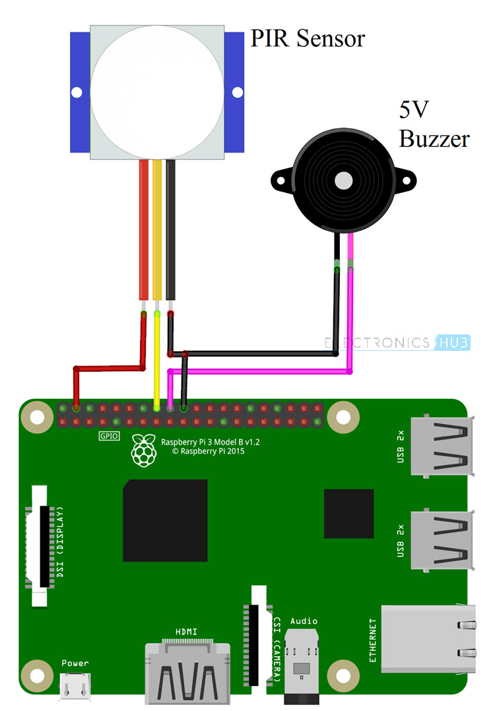

3.Arduino - Turn lrd -IR sensor

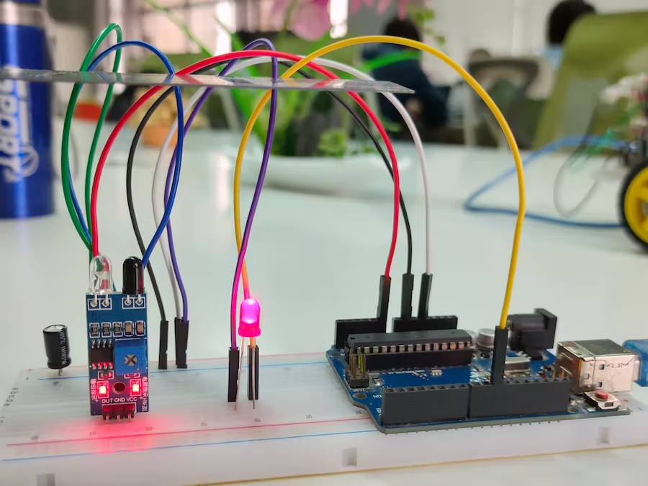

int analogInPin = A0;

int led =10;

int sensorValue = 0;

void setup() {

Serial.begin(9600);

pinMode(led, OUTPUT);

}

void loop() {

sensorValue = analogRead(analogInPin);

Serial.print("sensor = " );

Serial.println(sensorValue);

delay(200);

if(sensorValue<80)

{

digitalWrite(led,HIGH);

}

else

{

digitalWrite(led,LOW);

}

}

4.Rasberry PI- IR sensor - Turn led

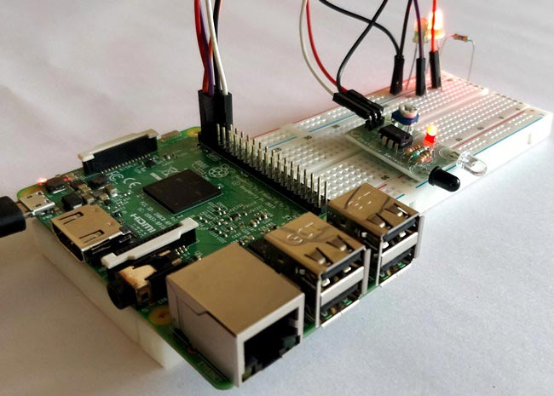

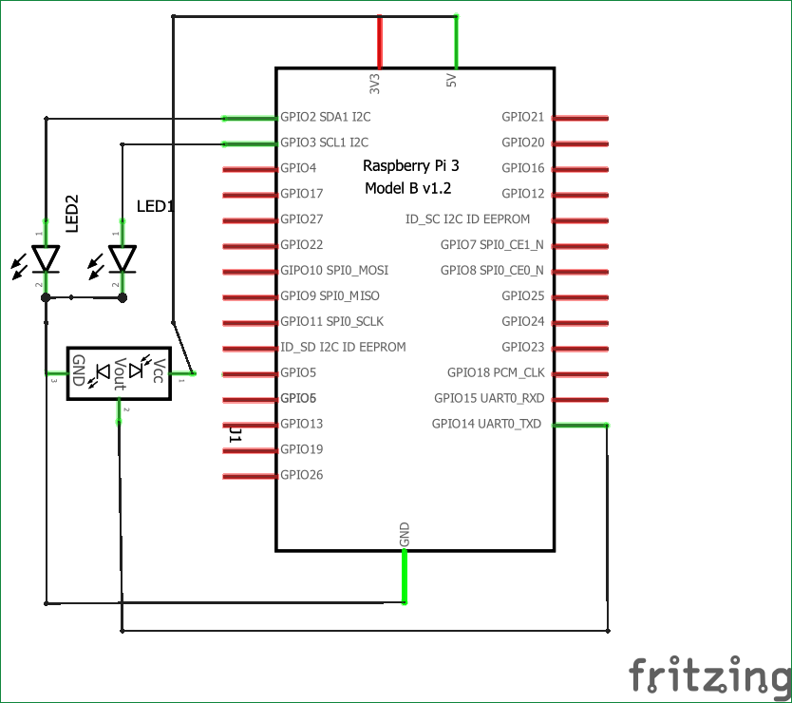

import RPi.GPIO as IO

import time

IO.setwarnings(False)

IO.setmode(IO.BCM)

IO.setup(2,IO.OUT) #GPIO 2 -> Red LED as output

IO.setup(3,IO.OUT) #GPIO 3 -> Green LED as output

IO.setup(14,IO.IN) #GPIO 14 -> IR sensor as input

while 1:

if(IO.input(14)==True): #object is far away

IO.output(2,True) #Red led ON

IO.output(3,False) # Green led OFF

if(IO.input(14)==False): #object is near

IO.output(3,True) #Green led ON

IO.output(2,False) # Red led OFF

1.Soil moisture sensor of soil using soil moisture sensor

int sensor_input=7;

int BUZZER=8;

void setup()

{

pinMode(sensor_input, INPUT);

pinMode(BUZZER, OUTPUT);

}

void loop()

output_value=digitalRead(sensor_input);

Serial.println(“Moisture…”)

Serial.println(output_value)

{

if(digitalRead(sensor_input)==HIGH)

{

digitalWrite(BUZZER, HIGH);

Serail.println(“soil is dry...”)

}

else

{

digitalWrite(BUZZER, LOW);

Serail.println(“soil is wet…”)

}

delay(1000);

}

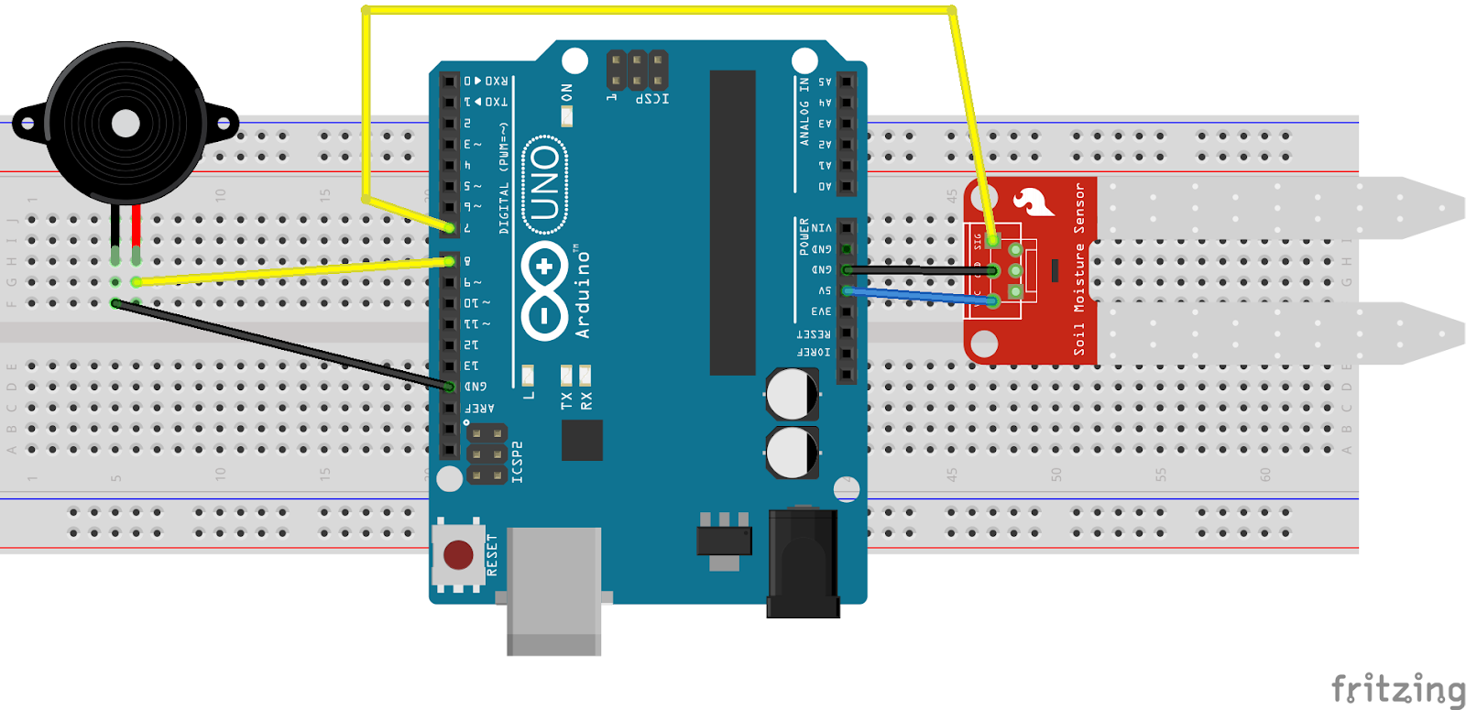

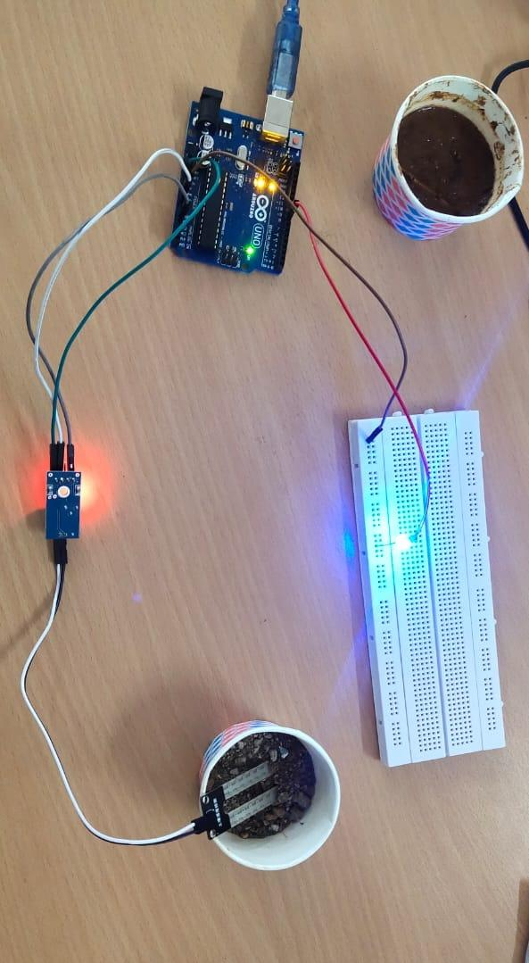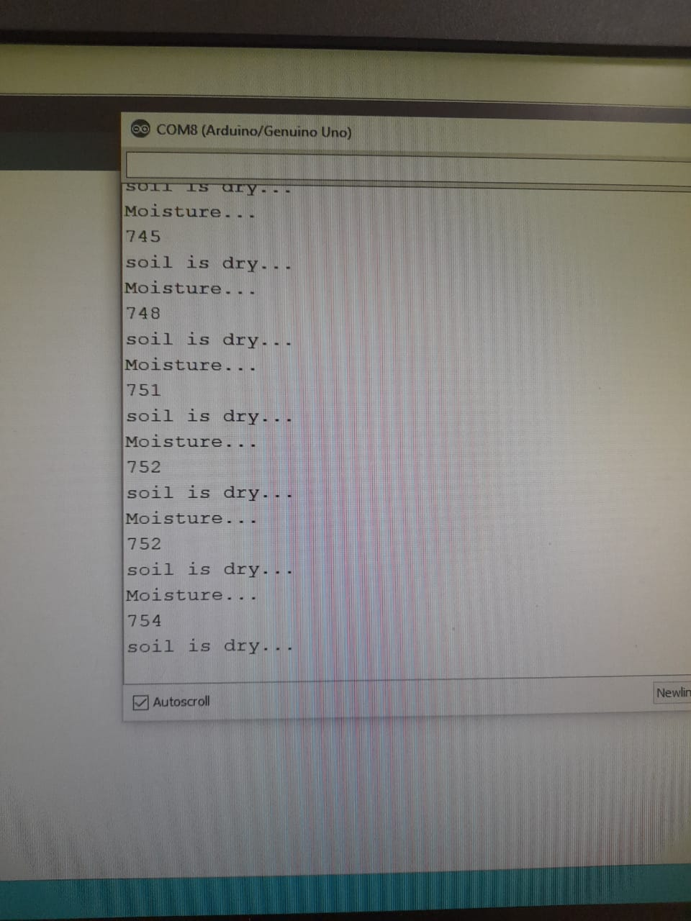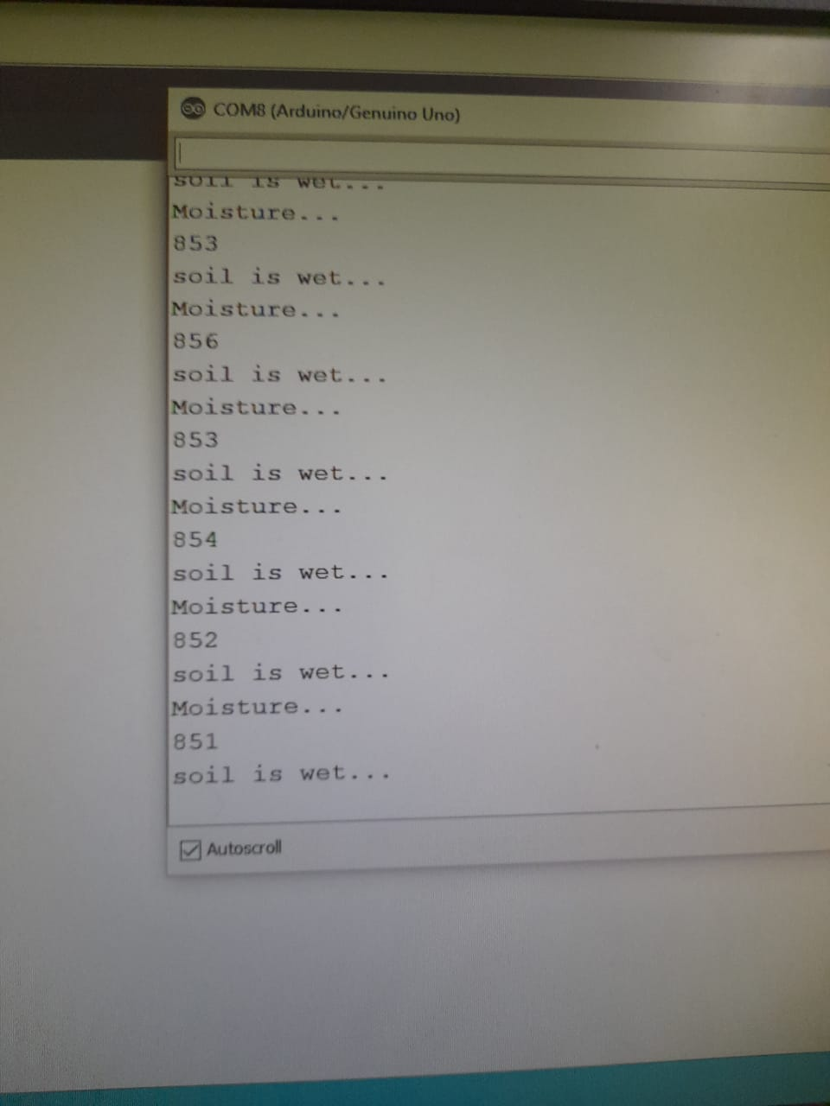

2.**Soil Moisture Sensor (Raspberry Pi)**

#!/usr/bin/python

import RPi.GPIO as GPIO

import time

channel = 21

GPIO.setmode(GPIO.BCM)

GPIO.setup(channel, GPIO.IN)

def callback(channel):

if GPIO.input(channel):

print "Water Detected!"

else:

print "Water Detected!"

GPIO.add_event_detect(channel, GPIO.BOTH, bouncetime=300)

GPIO.add_event_callback(channel, callback)

while True:

time.sleep(1)

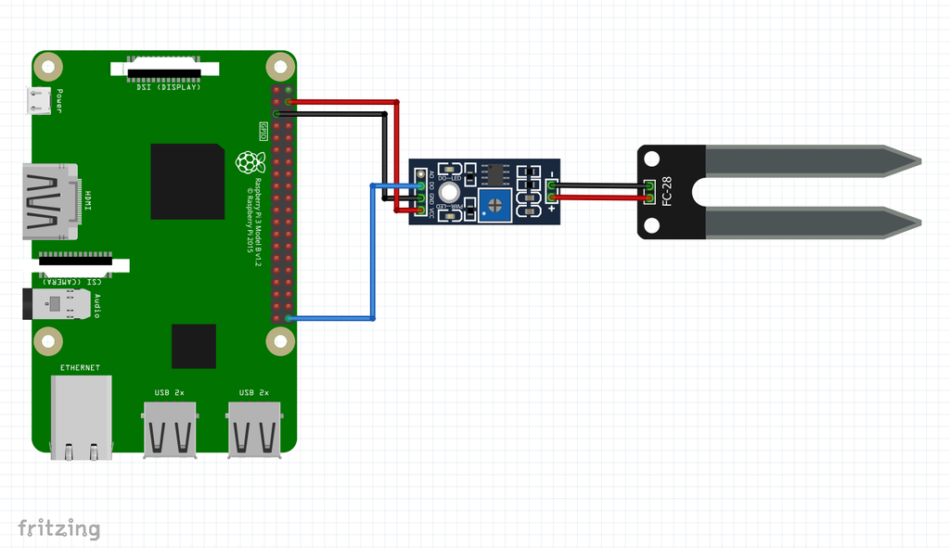

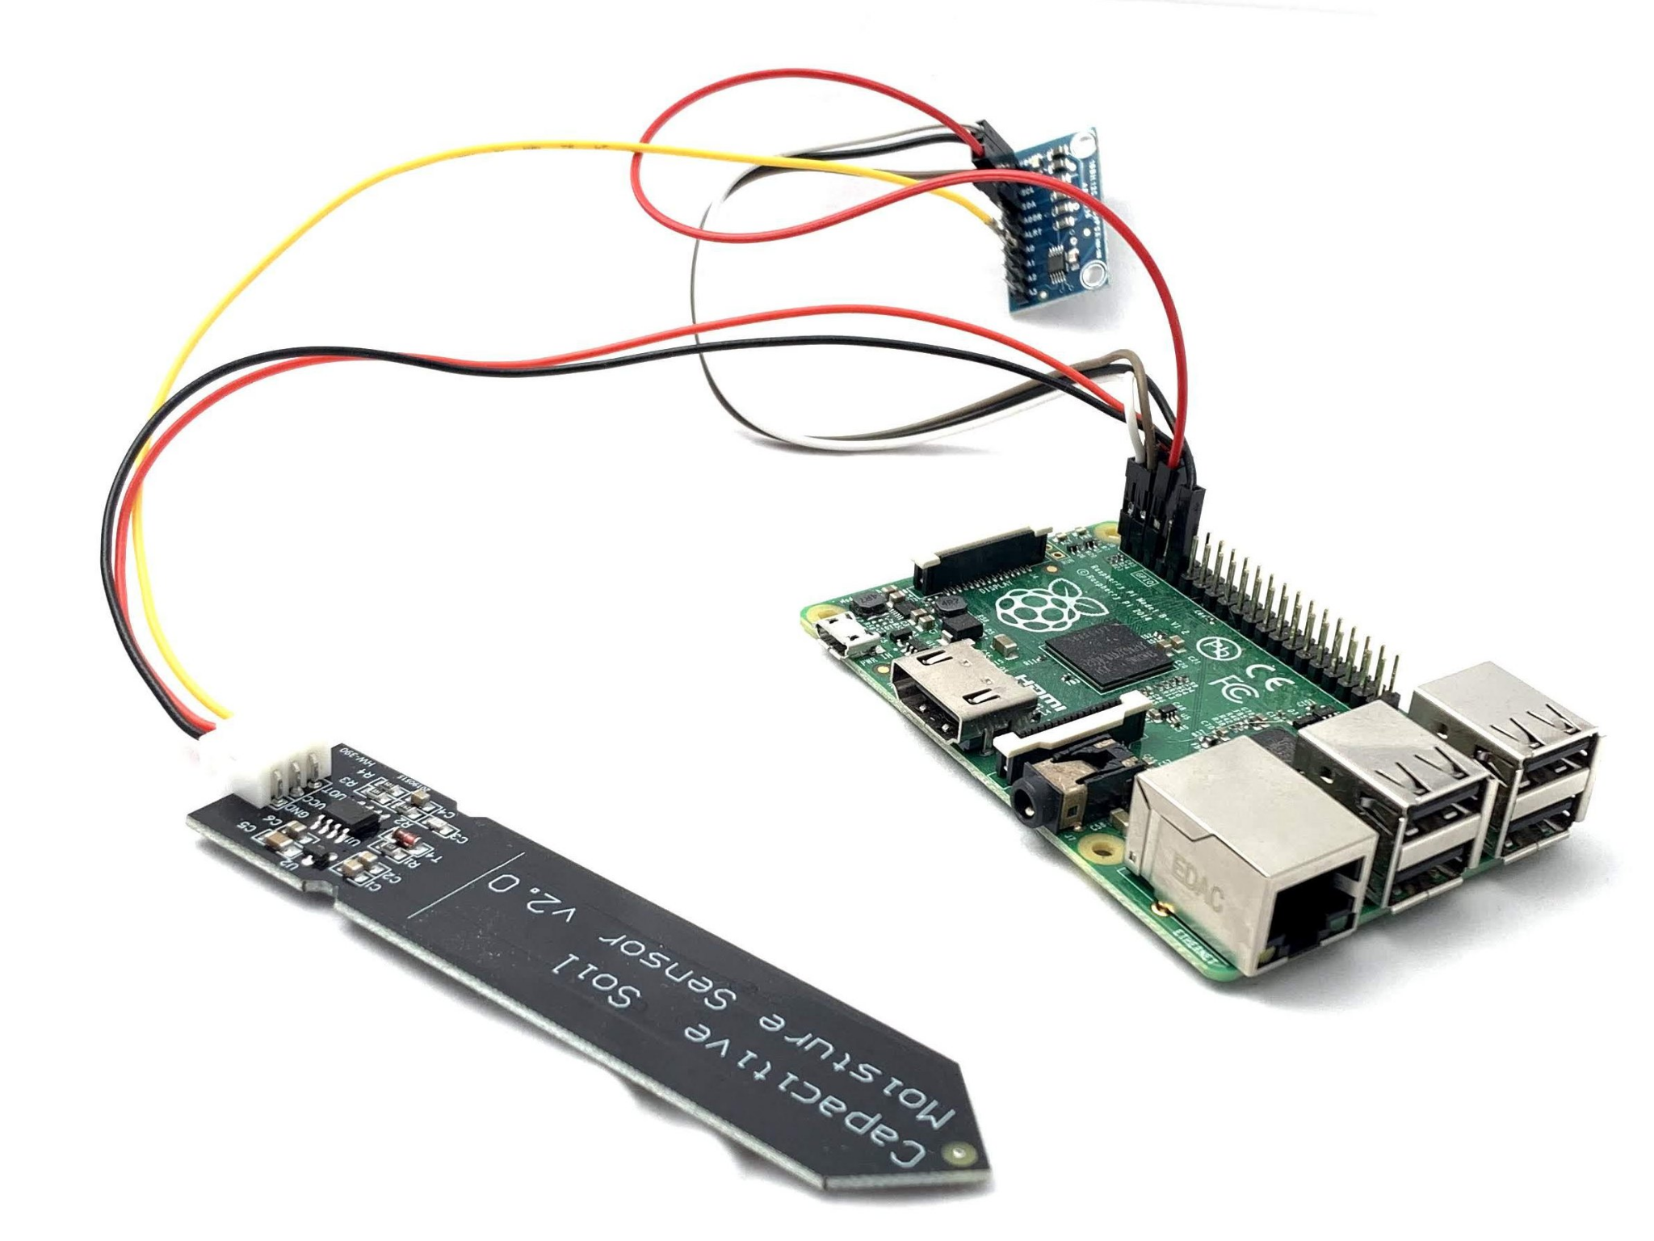

1.ultrasonic sensor - mesure distance -arduino

const int trigPin = 9;

const int echoPin = 10;

long duration;

int distance;

void setup() {

pinMode(trigPin, OUTPUT);

pinMode(echoPin, INPUT);

Serial.begin(9600);

}

void loop() {

digitalWrite(trigPin, LOW);

delayMicroseconds(2);

digitalWrite(trigPin, HIGH);

delayMicroseconds(10);

digitalWrite(trigPin, LOW);

duration = pulseIn(echoPin, HIGH);

distance = duration * 0.034 / 2;

Serial.print("Distance: ");

Serial.println(distance);

Serial.print("cm");

delay(10);

}

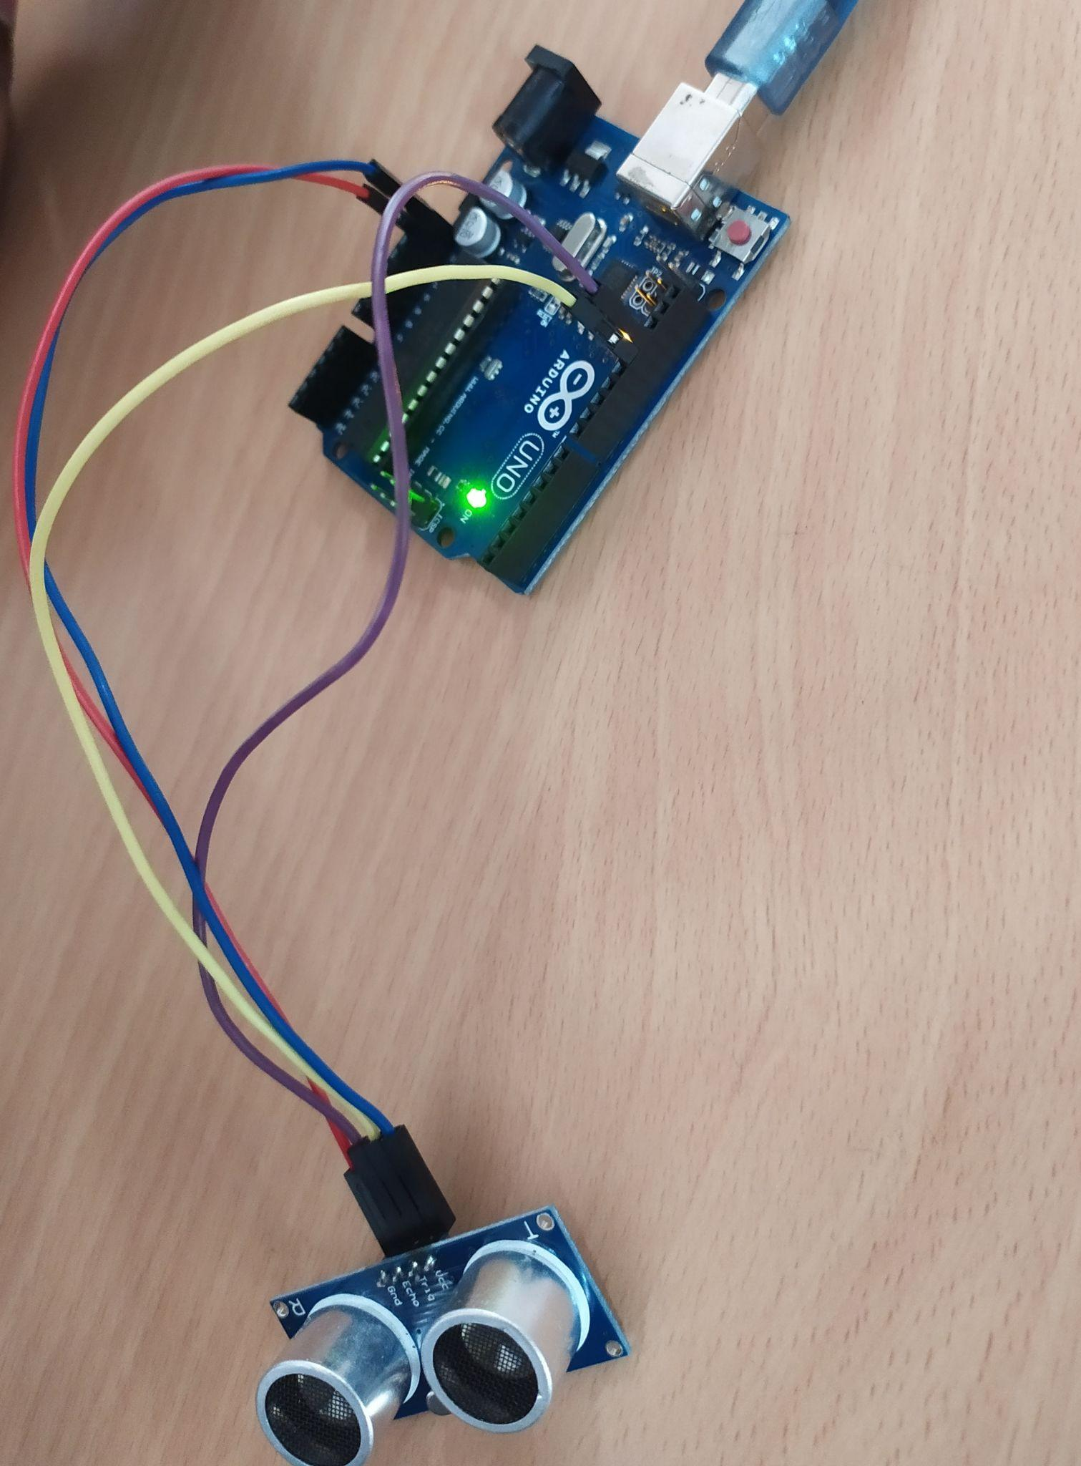

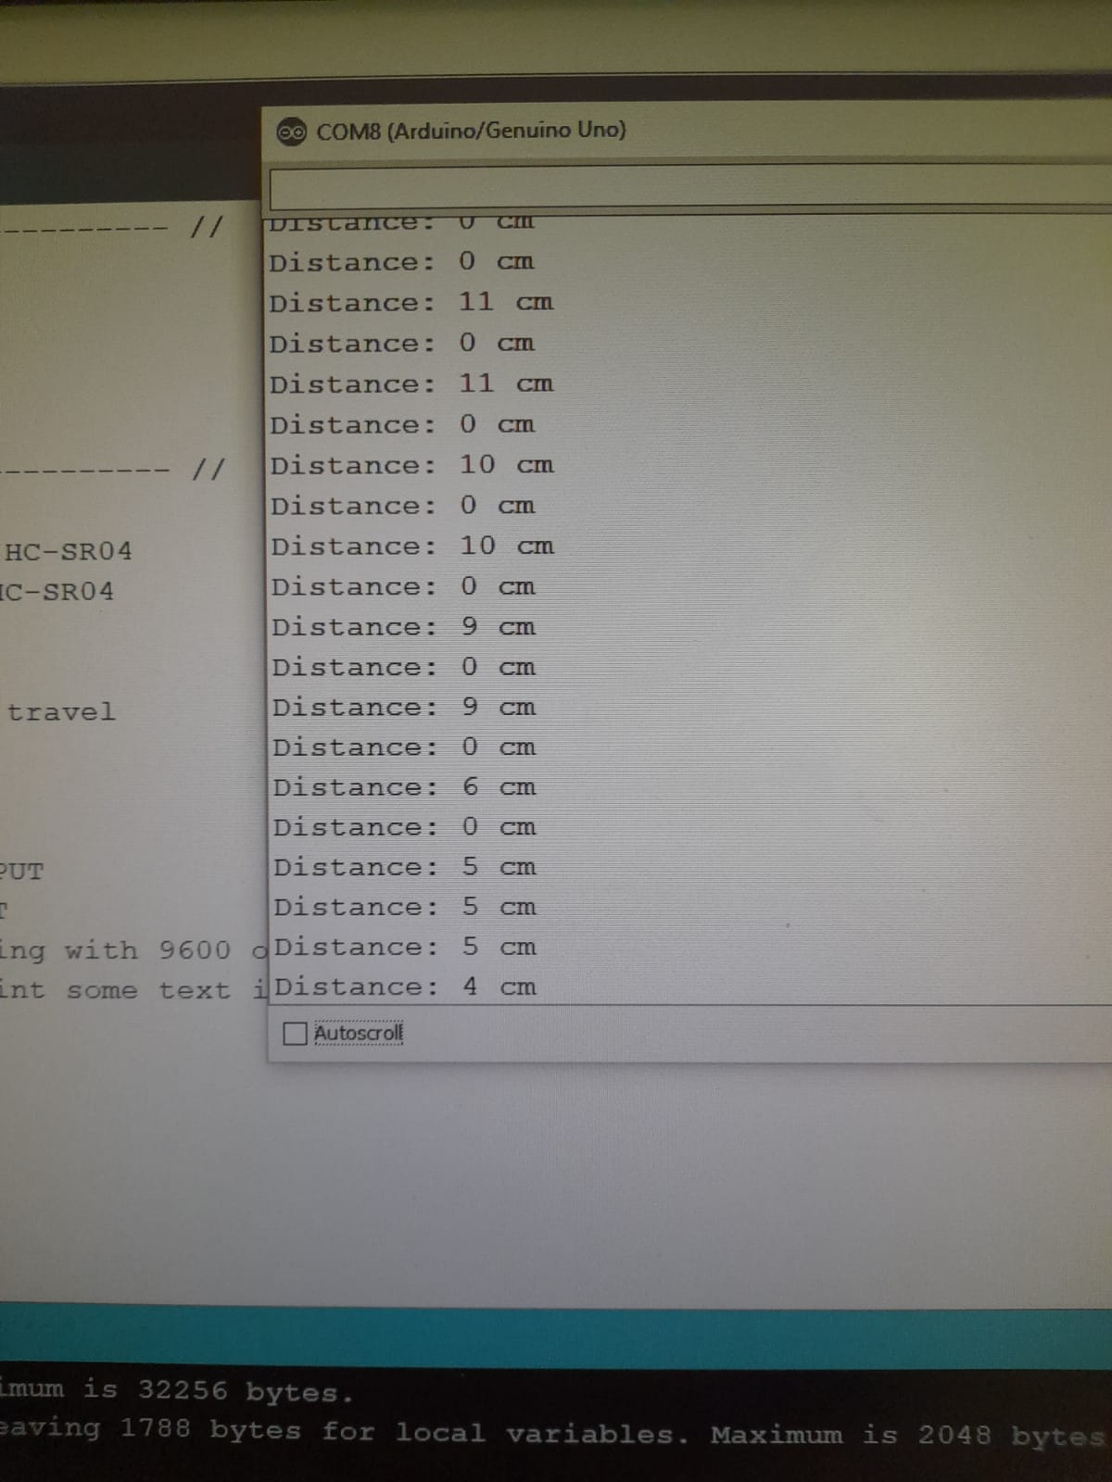

2.rasberry pi-ultrasonic sensor -

import RPi.GPIO as GPIO

import time

try:

GPIO.setmode(GPIO.BOARD)

pinTrigger = 7

pinEcho = 11

GPIO.setup(pinTrigger, GPIO.OUT)

GPIO.setup(pinEcho, GPIO.IN)

GPIO.output(pinTrigger, GPIO.LOW)

GPIO.output(pinTrigger, GPIO.HIGH)

time.sleep(0.00001)

GPIO.output(pinTrigger, GPIO.LOW)

while GPIO.input(pinEcho)==0:

pulseStartTime = time.time()

while GPIO.input(pinEcho)==1:

pulseEndTime = time.time()

pulseDuration = pulseEndTime - pulseStartTime

distance = round(pulseDuration * 17150, 2)

print("Distance: %.2f cm" % (distance))

finally:

GPIO.cleanup()

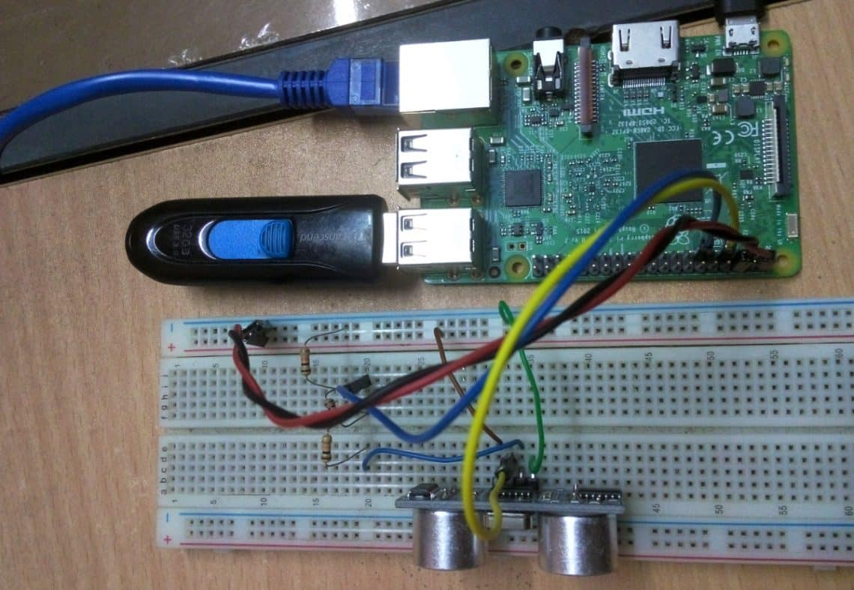



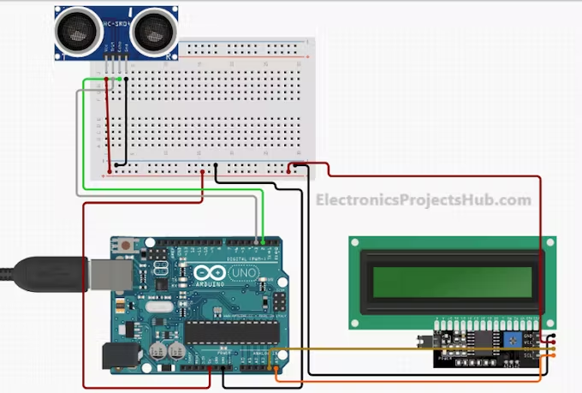

1.identify the leakage of gas/smoke in environment - arduino

int led_pin=2;

int Buzzer=4;

int analog_pin=A0;

void setup() {

Serial.begin(9600);

pinMode(led_pin, OUTPUT);

pinMode(Buzzer, OUTPUT);

}

void loop() {

int temp;

temp=analogRead(analog_pin);

Serial.println(temp);

if(temp>130)

{

Serial.println("Gas Detection!!");

digitalWrite(led_pin,HIGH);

digitalWrite(Buzzer,HIGH);

delay(1000);

digitalWrite(led_pin,LOW);

digitalWrite(Buzzer,LOW);

delay(1000);

}

else

{

Serial.println("No dangerous!");

digitalWrite(led_pin,LOW);

digitalWrite(Buzzer,LOW);

delay(500);

}

}

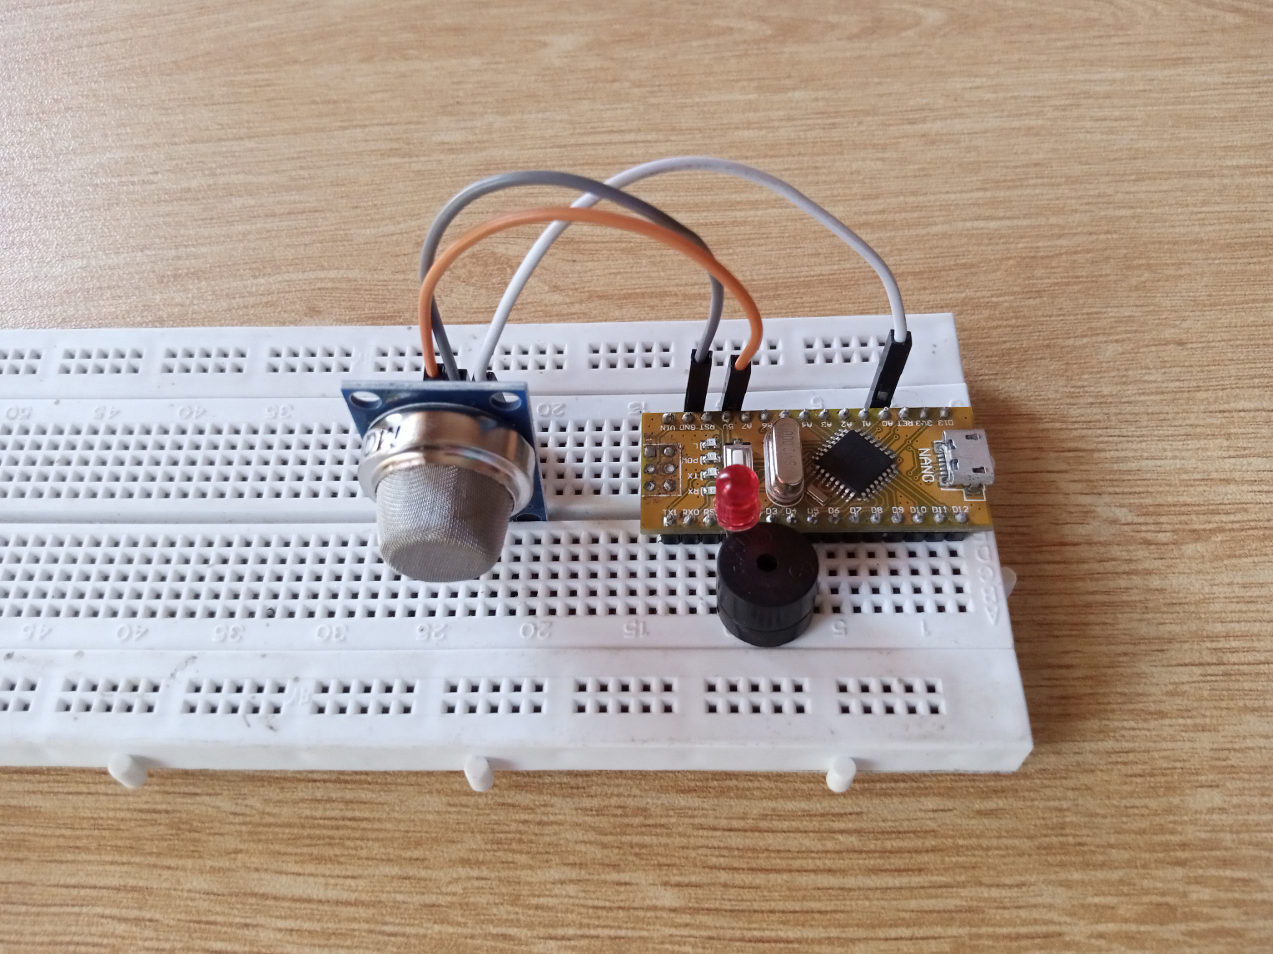

2.rasberry pi- smoke sensor

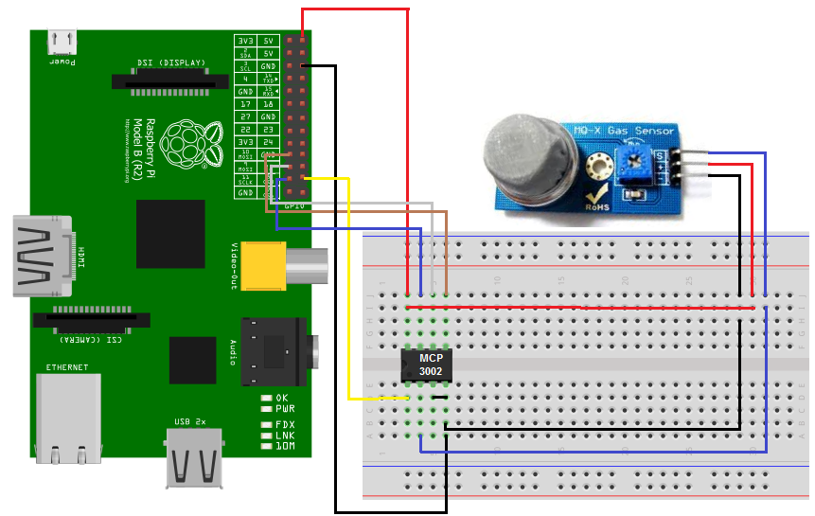

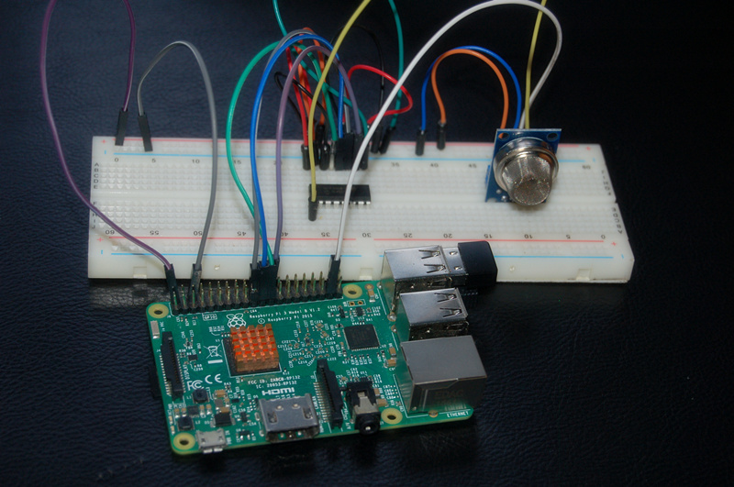

import time

import botbook_mcp3002 as mcp #

smokeLevel= 0

def readSmokeLevel():

global smokeLevel

smokeLevel= mcp.readAnalog()

def main():

while True: #

readSmokeLevel() #

print ("Current smoke level is %i " % smokeLevel) #

if smokeLevel > 120:

print("Smoke detected")

time.sleep(0.5) # s

if_name_=="_main_":

main()

1.arduino - humidity and temperatur - DHT 11 sensor

#include <dht.h>

#define dht_apin A0

void setup(){

Serial.begin(9600);

delay(500);

Serial.println("DHT11 Humidity & temperature Sensor\n\n");

delay(1000);

}

void loop(){

DHT.read11(dht_apin);

Serial.print("Current humidity = ");

Serial.print(DHT.humidity);

Serial.print("% ");

Serial.print("temperature = ");

Serial.print(DHT.temperature);

Serial.println("C ");

delay(5000);

}

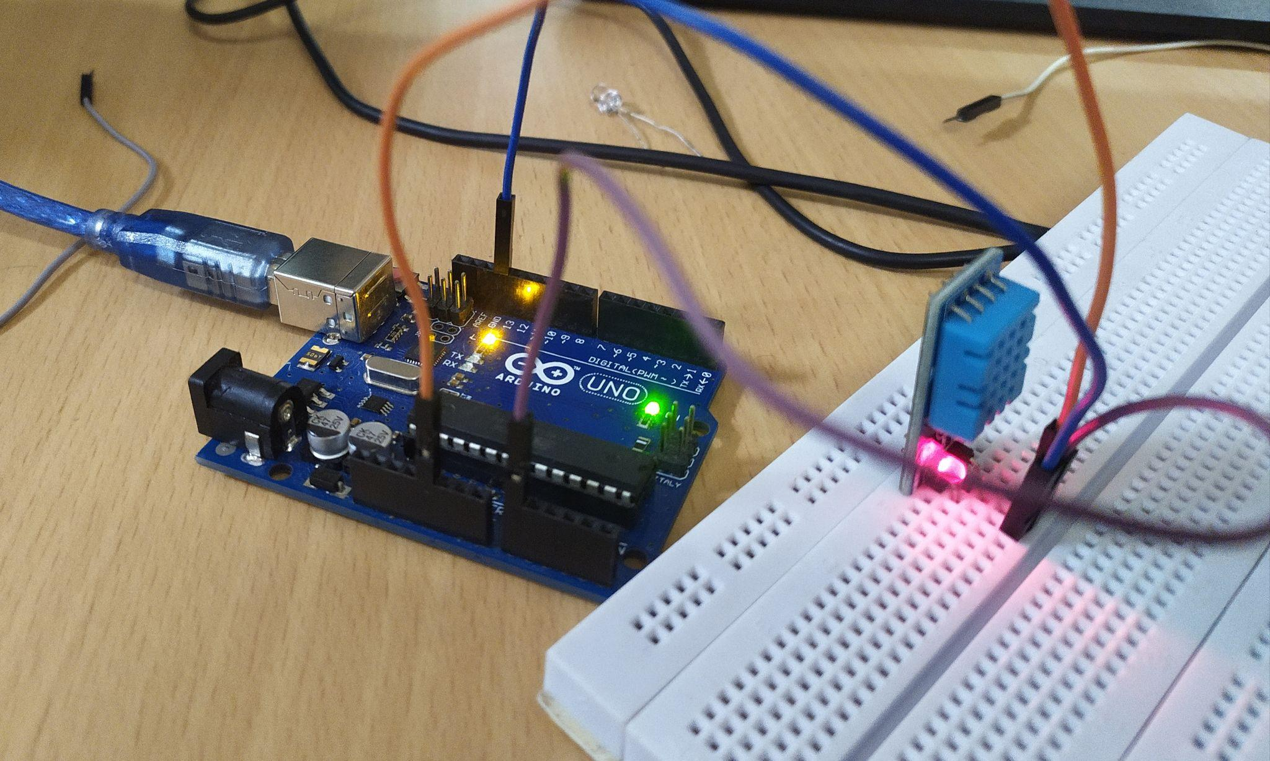

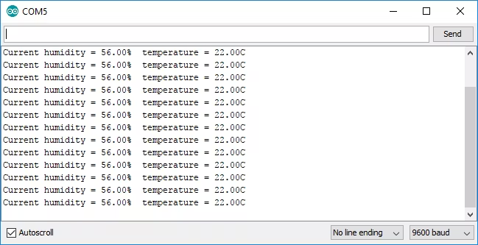

2.rasberry pi - humidity sensor - DHT 11 sensor

import time

import board

import adafruit_dht

import psutil

for proc in psutil.process_iter():

if proc.name() == 'libgpiod_pulsein' or proc.name() == 'libgpiod_pulsei':

proc.kill()

sensor = adafruit_dht.DHT11(board.D23)

while True:

try:

temp = sensor.temperature

humidity = sensor.humidity

print("Temperature: {}*C Humidity: {}% ".format(temp, humidity))

except RuntimeError as error:

print(error.args[0])

time.sleep(2.0)

continue

except Exception as error:

sensor.exit()

raise error

time.sleep(2.0)

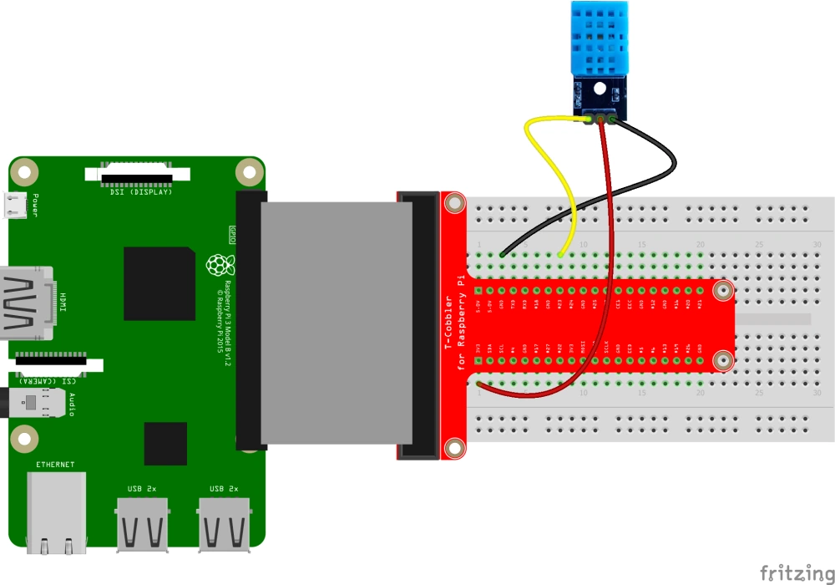

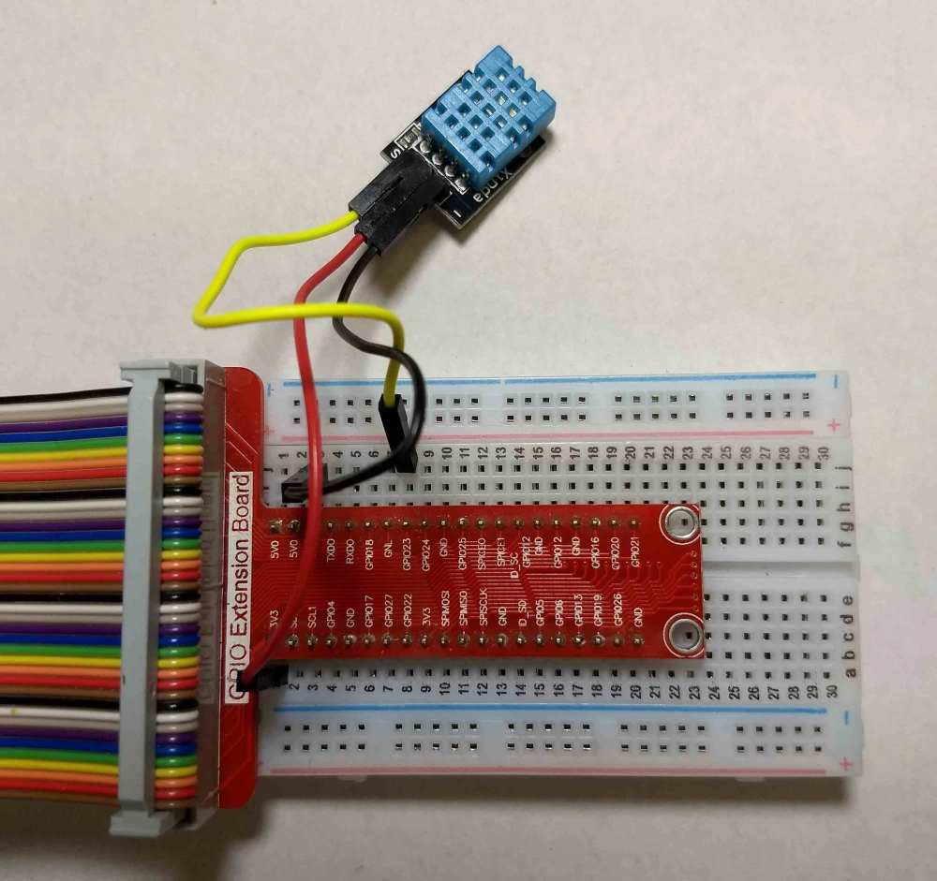

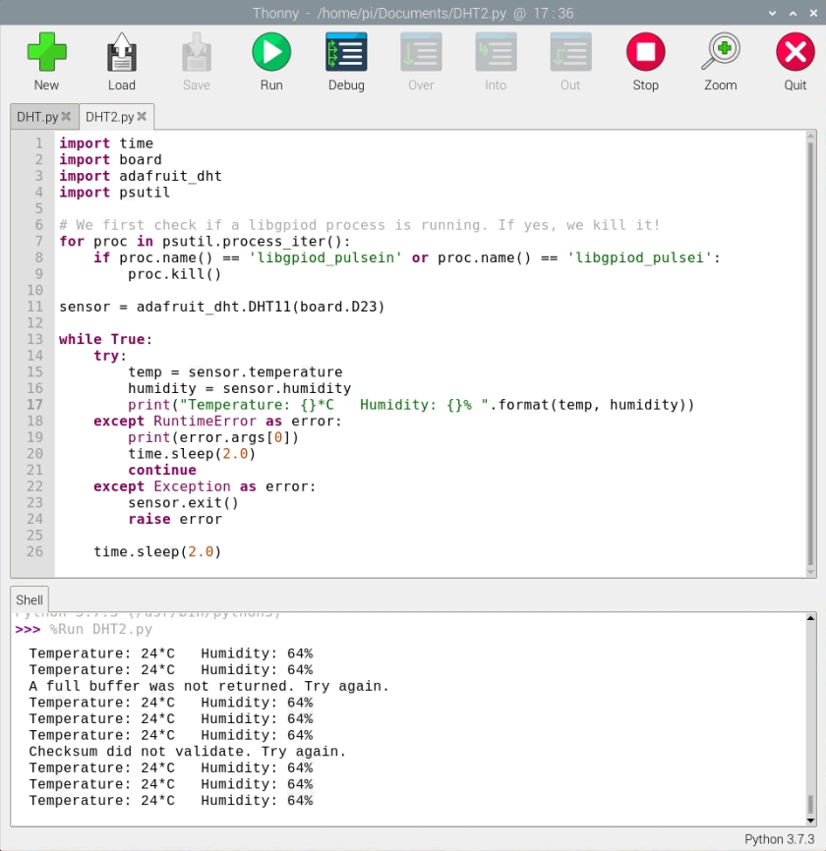

1.Bluetooth to control LED - arduino

void setup() {

Serial.begin(9600);

pinMode(8, OUTPUT);

}

void loop() {

if(Serial.available()>0)

{

char data= Serial.read();

switch(data)

{

case 'a': digitalWrite(8, HIGH);break;

case 'd': digitalWrite(8, LOW);break;

default : break;

}

Serial.println(data);

}

delay(50);

}

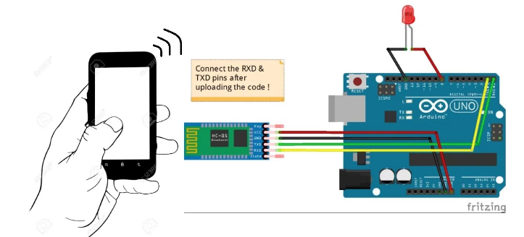

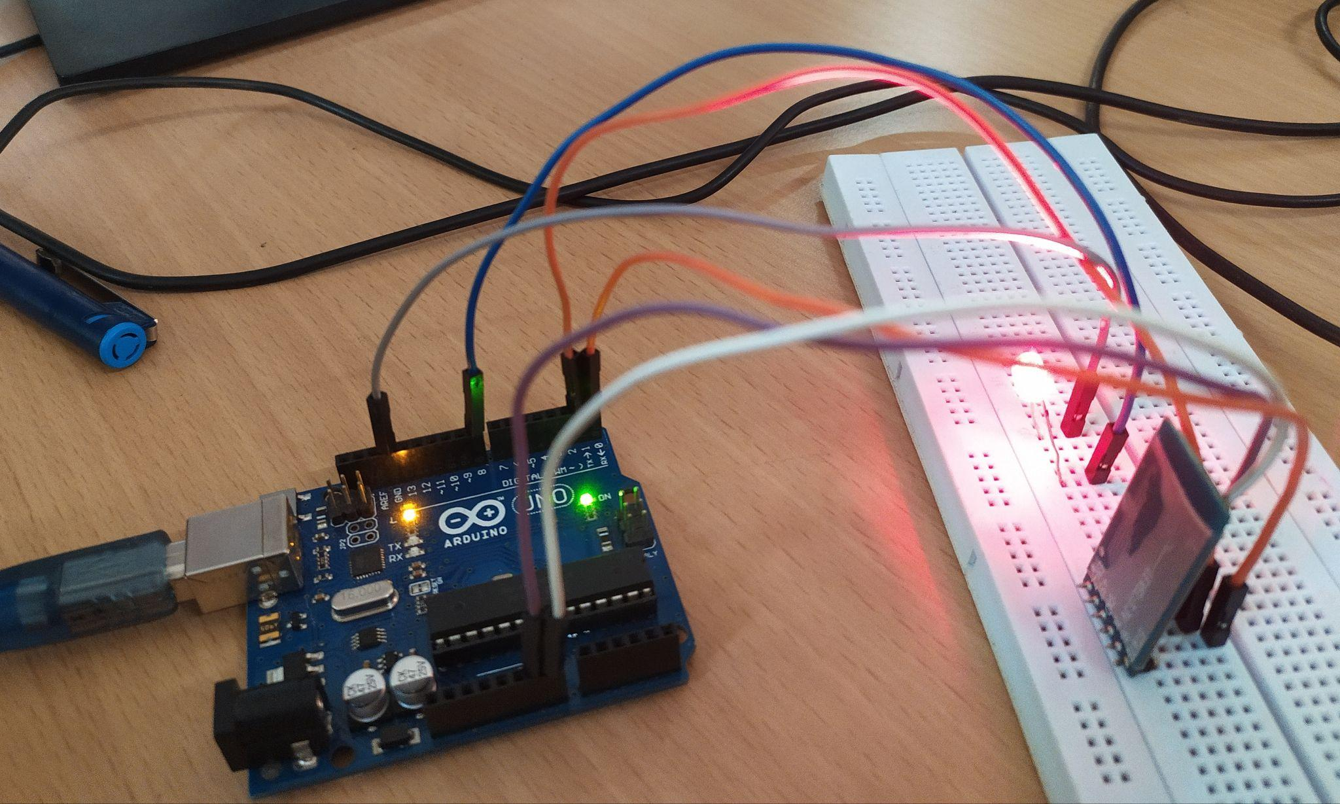

2.Bluetooth - control led - raspberry PI

from machine import Pin,UART

uart = UART(0,9600)

LedGPIO = 16

led = Pin(LedGPIO, Pin.OUT)

while True:

if uart.any():

command = uart.readline()

if command==b'\xd0':

led.high()

print("ON")

elif command==b'\xd5':

led.low()

print("OFF")

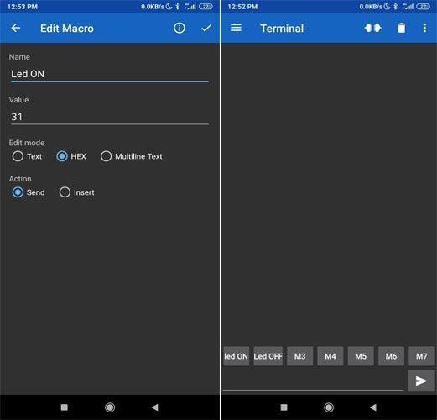

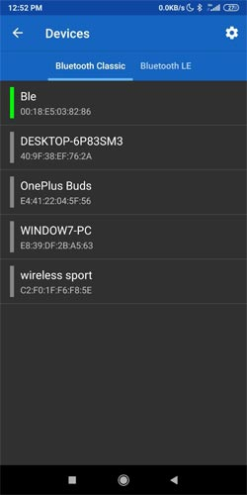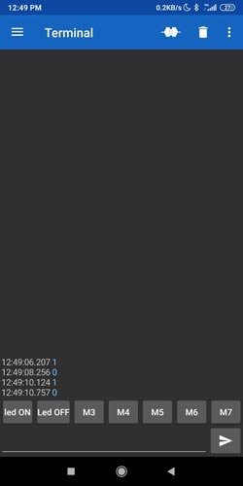

1.Control LED - relay switch - arduino

int Relaypin= 3;

void setup() {

pinMode(Relaypin, OUTPUT);

}

void loop() {

digitalWrite(Relaypin, HIGH);

delay(1000);

digitalWrite(Relaypin, LOW);

delay(1000);

}

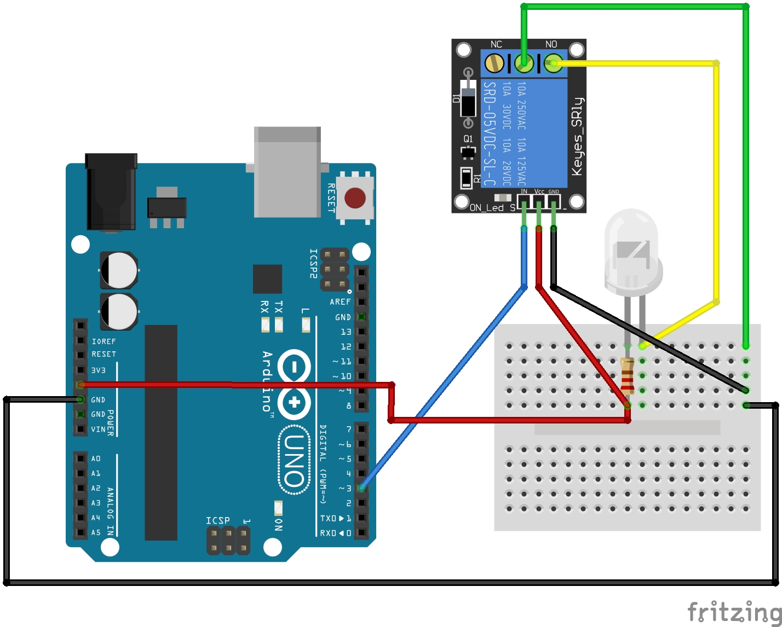

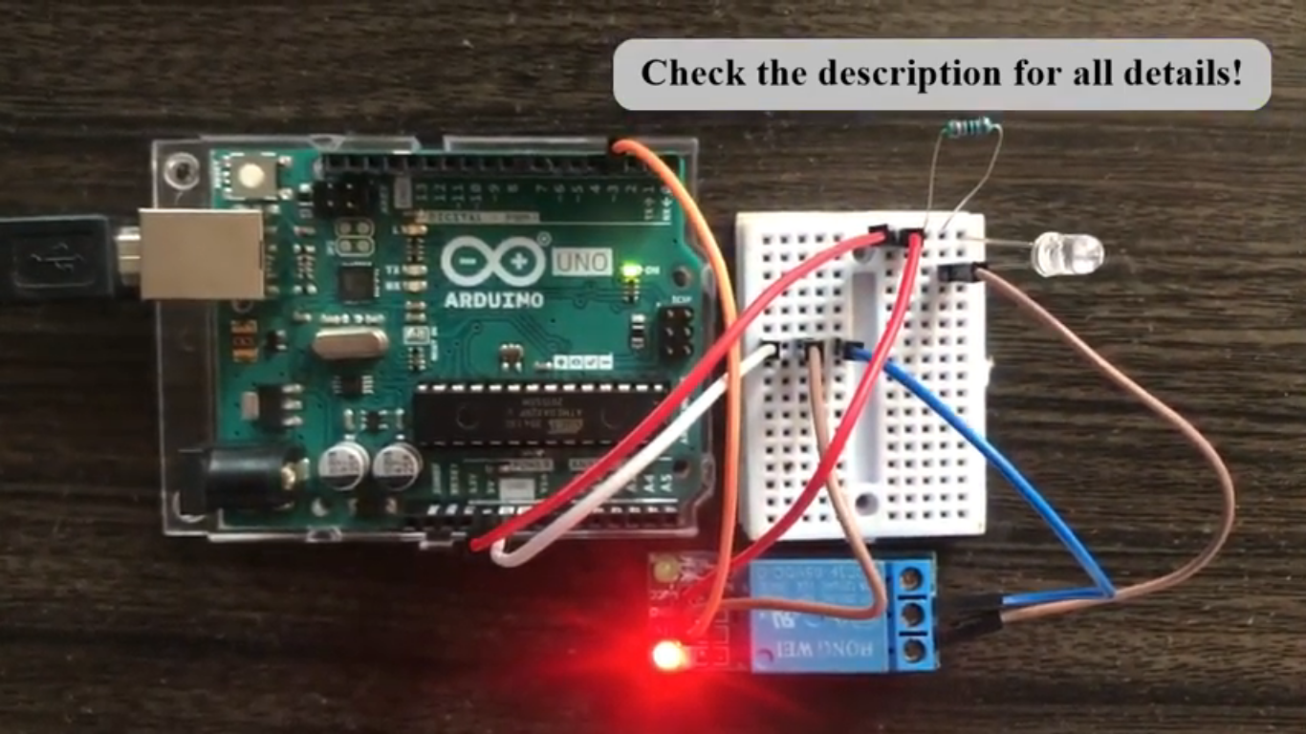

2.Rasberry pi- control relay switch

import RPi.GPIO as GPIO

import time

in1 = 16

in2 = 18

GPIO.setmode(GPIO.BOARD)

GPIO.setup(in1, GPIO.OUT)

GPIO.setup(in2, GPIO.OUT)

GPIO.output(in1, False)

GPIO.output(in2, False)

try:

while True:

for x in range(5):

GPIO.output(in1, True)

time.sleep(0.1)

GPIO.output(in1, False)

GPIO.output(in2, True)

time.sleep(0.1)

GPIO.output(in2, False)

GPIO.output(in1,True)

GPIO.output(in2,True)

for x in range(4):

GPIO.output(in1, True)

time.sleep(0.05)

GPIO.output(in1, False)

time.sleep(0.05)

GPIO.output(in1,True)

for x in range(4):

GPIO.output(in2, True)

time.sleep(0.05)

GPIO.output(in2, False)

time.sleep(0.05)

GPIO.output(in2,True)

except KeyboardInterrupt:

GPIO.cleanup()

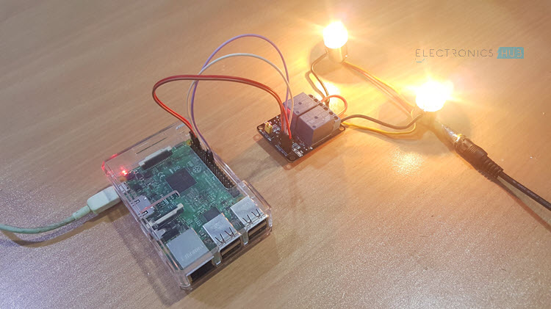

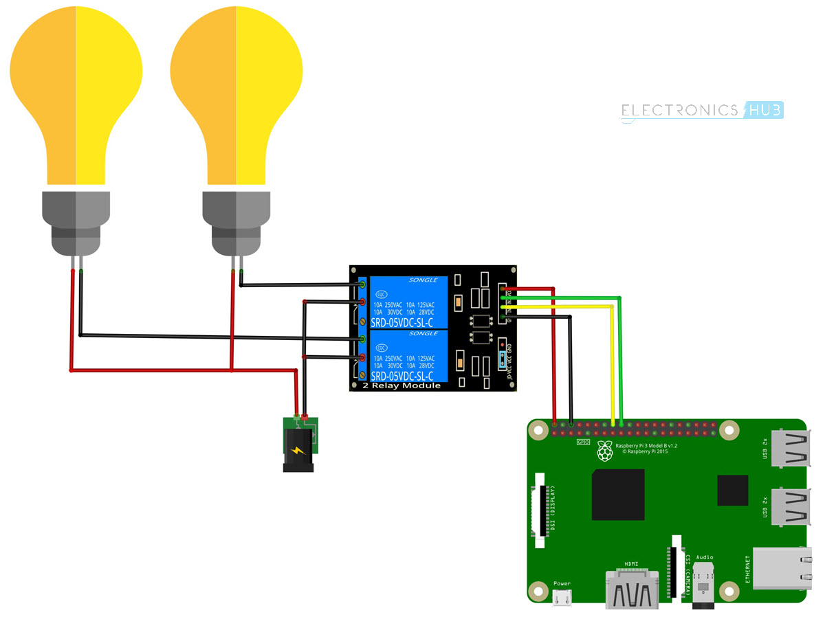

1.**HOW TO WRITE ARDUINO SENSOR DATA TO THE CLOUD**

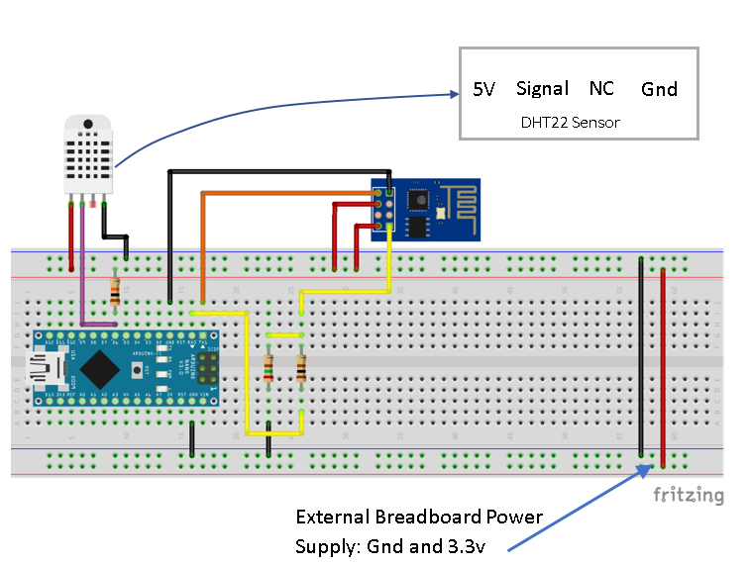

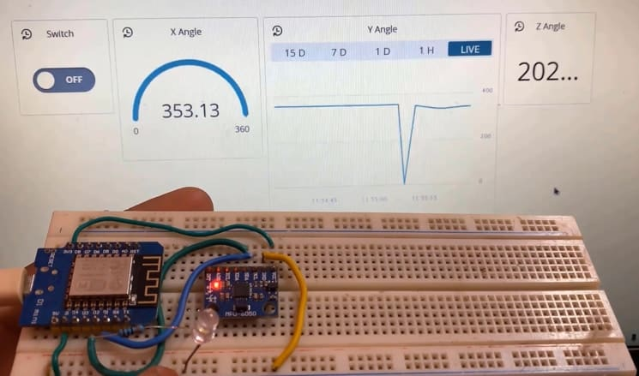

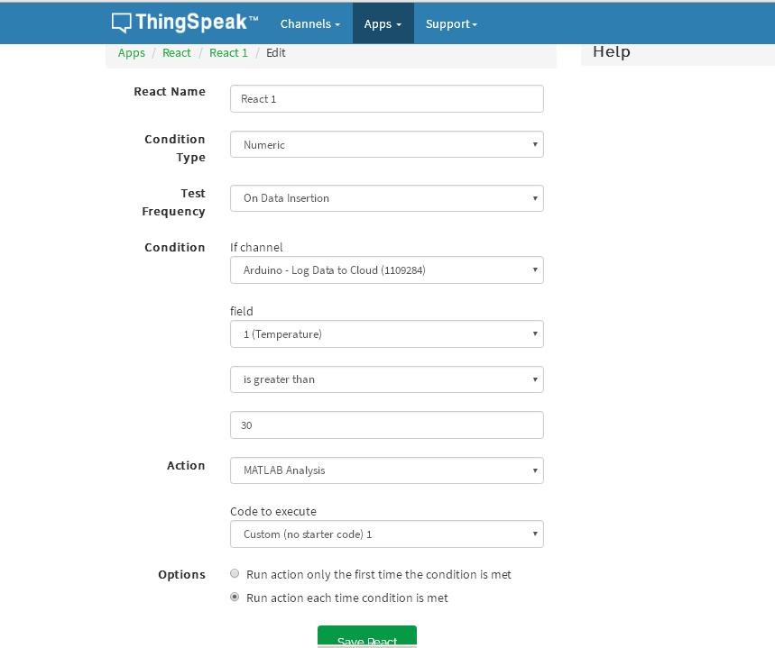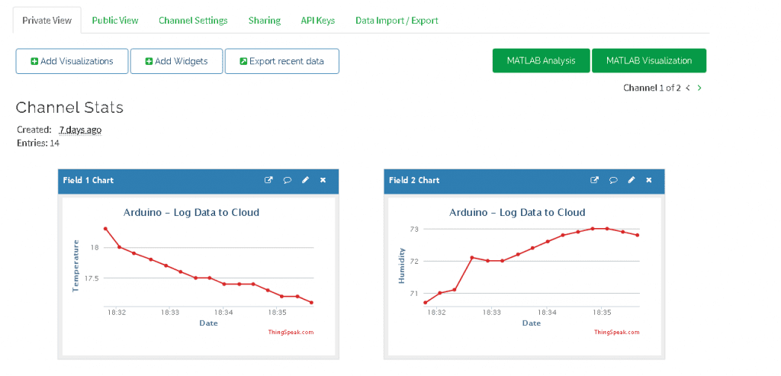

#include <SoftwareSerial.h>

#define RX 2

#define TX 3

#include "DHT.h"

#define DHTPIN 6

#define DHTTYPE DHT22

DHT dht(DHTPIN, DHTTYPE);

String AP = "AndroidAP_7822";

String PASS = "485088c2825f";

String API = "DRMINLS2DN88G1EZ";

String HOST = "api.thingspeak.com";

String PORT = "80";

String field1 = "field1";

String field2 = "field2";

int countTrueCommand;

int countTimeCommand;

boolean found = false;

float TempSensor = 1;

float HumidSensor = 1;

SoftwareSerial esp8266(RX,TX);

void setup() {

Serial.begin(9600);

esp8266.begin(9600);

dht.begin();

delay(1000);

sendCommand("AT",5,"OK");

sendCommand("AT+CWMODE=1",5,"OK");

sendCommand("AT+CWJAP=\""+ AP +"\",\""+ PASS +"\"",20,"OK");

}

void loop() {

TempSensor = getTempData();

HumidSensor = getHumidData();

String getData = "GET /update?api_key="+ API +"&"+ field1 +"="+String(TempSensor)+"&"+ field2 +"="+String(HumidSensor);

sendCommand("AT+CIPMUX=1",5,"OK");

sendCommand("AT+CIPSTART=0,\"TCP\",\""+ HOST +"\","+ PORT,15,"OK");

sendCommand("AT+CIPSEND=0," +String(getData.length()+4),4,">");

esp8266.println(getData);delay(1500);countTrueCommand++;

sendCommand("AT+CIPCLOSE=0",5,"OK");

}

float getTempData(){

delay(2000);

float t = dht.readTemperature();

if (isnan(t)) {

Serial.println("Failed to read from DHT sensor!");

return 0;

}

return t;

}

float getHumidData(){

delay(2000);

float h = dht.readHumidity();

if (isnan(h)) {

Serial.println("Failed to read from DHT sensor!");

return 0;

}

return h;

}

void sendCommand(String command, int maxTime, char readReplay[]) {

Serial.print(countTrueCommand);

Serial.print(". at command => ");

Serial.print(command);

Serial.print(" ");

while(countTimeCommand < (maxTime*1))

{

esp8266.println(command);//at+cipsend

if(esp8266.find(readReplay))//ok

{

found = true;

break;

}

countTimeCommand++;

}

if(found == true)

{

Serial.println("OK");

countTrueCommand++;

countTimeCommand = 0;

}

if(found == false)

{

Serial.println("Fail");

countTrueCommand = 0;

countTimeCommand = 0;

}

found = false;

}

2.Rasberry pi - data storage in cloud

import serial

from time import *

import datetime, string

import Adafruit_DHT

Host = "api.thingspeak.com"

Port = "80"

API="IUKIV2ZREByERH7V47Q"

field1 = "field1"

field2 = "field2"

DHT_SENSOR = Adafruit_DHT.DHT22

DHT_PIN = 4

port = serial.Serial("/dev/ttyAMA0", baudrate=115200, timeout=3.0)

def readlineCR(port):

rv = ""

rv = port.read(1000)

return rv

def wifiCommand( sCmd, waitTm=1, sTerm='OK' ):

lp = 0

ret = ""

print

print "Cmd: %s" % sCmd

port.flushInput()

port.write( sCmd + "\r\n" )

ret = port.readline()

sleep( 0.2 )

while( lp < waitTm ):

while( port.inWaiting() ):

ret = port.readline().strip( "\r\n" )

print ret

lp = 0

if( ret == sTerm ): break

if( ret == 'ERROR' ): break

sleep( 1 )

lp += 1

return ret

isConnected=True;

while isConnected:

port.write("AT\r\n")

returnedData=readlineCR(port)

print(returnedData)

if "OK" not in returnedData :

time.sleep(20)

else :

isConnected=False

port.write("AT+CWMODE=1\r\n")

returnedData=readlineCR(port)

print(returnedData)

port.write("AT+CWJAP=\"AndroidAP_7822\",\"485088c2825f\"\r\n")

returnedData=readlineCR(port)

print(returnedData)

humidity, temperature = Adafruit_DHT.read_retry(DHT_SENSOR, DHT_PIN)

if humidity is not None and temperature is not None:

print("Temp={0:0.1f}*C Humidity={1:0.1f}%".format(temperature, humidity))

else :

print("Failed to retrieve data from humidity sensor")

port.write("AT+CIPMUX=1\r\n")

returnedData=readlineCR(port)

print(returnedData)

wifiCommand("AT+CIPSTART=0,\"TCP\",\""+ Host+"\","+Port,15,"OK")

returnedData=readlineCR(port)

print(returnedData)

cmd="Get /update?api_key="+API+"&"+field1+"="+str(20)+"&"+field2+"="+str(79)

cmdLn=str(len(cmd)+4)

wifiCommand("AT+CIPSEND=0,"+cmdLn,4,">")

returnedData=readlineCR(port)

print(returnedData)

port.write(cmd)

port.write('\r')

returnedData=readlineCR(port)

print(returnedData)

Break

